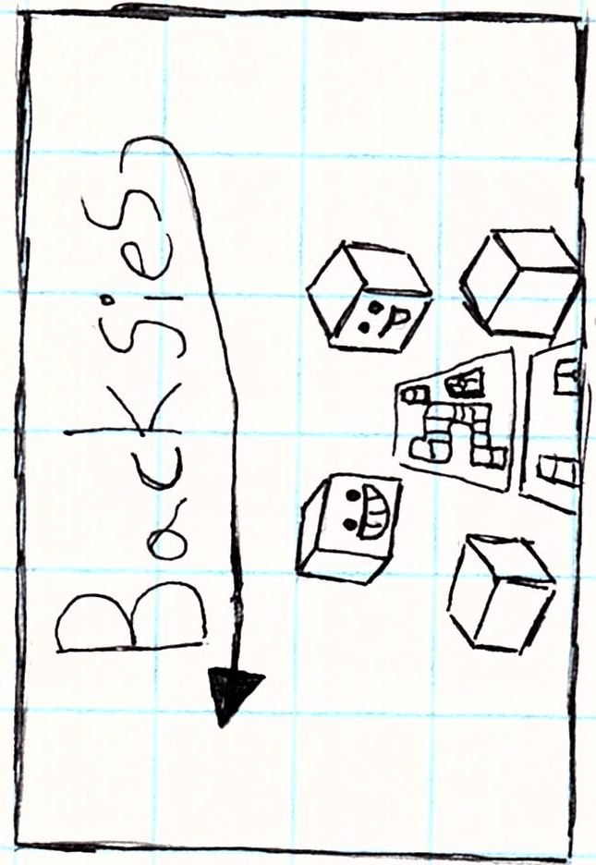

Welcome to Backsies!

Backsies is a dice rolling, card drawing board game developed by Tripoint games.

-The rules-

The rules to backsies are simple: when it is your turn you roll the die; getting a back moves you back 1 space, x moves you forward one, Z Lets You Move forward 1 or 2 Spaces, and Y makes you draw a card. If you go forward onto a card Space You draw a card, you don't draw if You go back onto a card Space.

If you go forward or back onto a Jump space you go to the attached Jump space. If You go forward onto a back you go to the attached back ; but if you go back onto a back You can stay on it, and if You get a second back you go up to the back.

-﻿special rules-

* Negative Zone

The negative zone is a place you go to When you draw a card that sends You to the negative Zone. When it is your turn in the negative Zone you will roll the dice; and if you get a X,Y, or z You get out of the negative zone and are Put on the jump space closest to the most people, but if you get

a back you draw a frontsies card and You will go back a space and draw a Frontsies card.

* The Void

When You go back 5 times in the negative zone you will enter the Void. The Void Makes You draw a trait card and will put you at the back space closest to the most number of players.